Target Keyword Cluster: Vedic forest science | afforestation farmland Karnataka | Nakshatra Vana farmland | Navagraha Vana farmland | reforestation farmland near Kabini | biodiversity restoration Kabini | seed bank farmland Karnataka | farmland near Wayanad Bandipur | managed farmland near Bangalore | gated farm community
Featured Thumbnail HTML: <img src="going-back-to-our-roots-vedic-forest-science-anantavana.jpg" alt="reforestation farmland near Kabini" />
Secondary Image Alt Tags: alt="Vedic forest science Vanatvam" | alt="Nakshatra Vana Navagraha Vana sacred grove" | alt="Kabini biodiversity hotspot farmland"
Meta Title: Going Back to Our Roots: Vedic Forest Science at AnantaVana, Kabini | Vanatvam
Meta Description: How Vedic forest science and sacred Vanas shape AnantaVana, Vanatvam's reforestation farmland in Kabini — rebuilding a seed bank for lost biodiversity in a gated, managed farm community built on afforestation, not monoculture.
URL slug: /blog/going-back-to-our-roots-vedic-forest-science/ (confirm against live site structure)
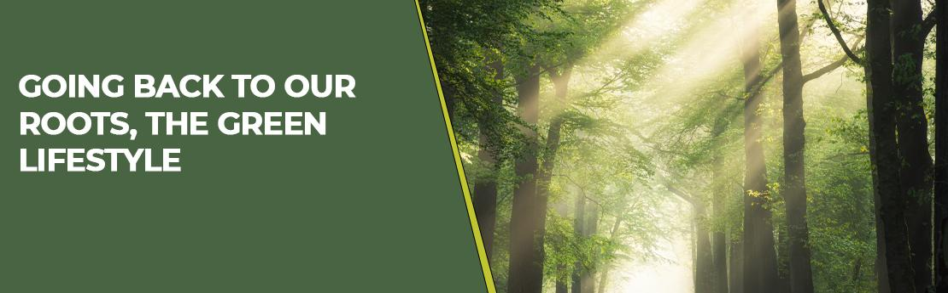

Going Back to Our Roots: The Green Lifestyle
As human civilization moves towards more advancement and urbanization, life in cities is becoming chaotic. The world today is facing the threat of global warming and climate change. Sustaining the pace of development with access to clean air, good quality water and healthy food — which was well managed in the past — is now under serious threat. Rainfall has become unpredictable, air pollution in big cities has reached all-time high levels of emissions, and food doesn't grow anymore without supplements. In most cases, the 'food' that is grown contains heavy metals, harmful chemical residues, and lacks the nutrients it once had.
Is this the real development that humans have been working so hard for? Is this good for sustaining a good quality of life on earth? How many more years can we continue down this path before we reach a point of no return? Farmers are selling the agricultural lands that once fed us, and that land is being used to set up industries and buildings instead. Where, then, will we be able to get good quality food?

Going back to our roots
The answer to this challenge is to go back to our roots and revive Vedic forest science [<b><a href="/">Vedic forest science</a></b>]. Our ancestors created forests through meticulous planning — protecting tree species and systematically planting them to build vast tracts of forest. More than 70% of food once came from forests. Fruits, vegetables and herbs for medicine were grown in the 'forest,' known as Vanas. We need to rediscover these methods and revive the forests. At the core of Vanatvam's philosophy is a commitment to revive forest science and develop Vanas [<b><a href="/">afforestation farmland</a></b>] that become self-sustaining after a few years of care — afforestation farmland in Karnataka [<b><a href="/">afforestation farmland projects in Karnataka</a></b>], not monoculture plantations.

Sacred groves, carried from ancient texts to every Vanatvam farm
As ardent believers in reviving Vedic forest science, we develop Vanas, or mini-forest patches, such as Nakshatra Vana [<b><a href="/">Nakshatra Vana</a></b>], Panchavati Vana, Saraswati Vana [<b><a href="/">Saraswati Vana</a></b>], Navagraha Vana [<b><a href="/">Navagraha Vana</a></b>] and more — inspired by the Brihat Samhita and other Vedic farming and heritage groves in Karnataka [<b><a href="/">Vedic farming and heritage groves</a></b>], adding a spiritual dimension to raw nature. To further add to the experience, water bodies are incorporated into the community farms, and along with the music of rustling leaves, they give everyone a heavenly feeling.

Where this comes alive: AnantaVana, rebuilding a seed bank in Kabini
This philosophy is not an abstraction — it is the work underway at AnantaVana, our reforestation farmland in Kabini [<b><a href="/anantavana/">reforestation farmland in Kabini</a></b>]. Kabini sits within a historic biodiversity hotspot [<b><a href="/anantavana/">biodiversity hotspot</a></b>], where the forests of Karnataka, Kerala and Tamil Nadu once met in an unbroken stretch, close to Wayanad, Bandipur and the other towns that ring this green belt. But decades of clearing have thinned much of that tree cover, and with it, the diversity the region once held.
At AnantaVana, we are restoring the green cover one Vana at a time, planting a wide mix of native species to build what is, in effect, a seed bank [<b><a href="/anantavana/">seed bank farmland</a></b>] — fruit, seed and nectar that birds and animals can carry back out into the surrounding landscape. We can't restore a forest overnight, but we can plant the seed and give it the years it needs. Over time, we hope this quiet work helps the wider biodiversity of this Kabini-Wayanad-Bandipur belt find its way back.
AnantaVana is designed as a gated farm community [<b><a href="/anantavana/">gated farm community</a></b>], so families get the privacy and settled safety of a planned community while the Vanas take root around them. It is managed farmland within reach of Bangalore and Mysore [<b><a href="/anantavana/">managed farmland near Mysore</a></b>] — land you can be part of restoring, not just owning.
More than a gated address, AnantaVana is a community of like-minded, eco-conscious families [<b><a href="/anantavana/"> Eco-Conscious families</a></b>]who share this same conviction — that the land deserves as much care as it gives. Each member supports the conservation effort already underway here, with the shared goal of giving back to nature rather than simply taking from it.
Going back to our roots is not nostalgia. It is a practical, grounded path to a greener, healthier life — for us, and for the generations after us. For more information, visit Vanatvam.com.
Follow us on socials: Facebook, Instagram, YouTube, X (Twitter), LinkedIn.

Frequently Asked Questions

What is Vedic forest science?
Vedic forest science is the traditional knowledge our ancestors used to plan, protect and plant forests systematically. These forests supplied more than 70% of the food — fruits, vegetables and medicinal herbs — and sustained themselves with little intervention. Vanatvam is reviving these methods across its afforestation farmland projects [<b><a href="/">afforestation farmland</a></b>] in Karnataka.

Can non-agriculturists buy farmland in Karnataka?
Yes. Following the 2020 amendment to the Karnataka Land Reforms Act, individuals without an agricultural background can purchase agricultural land in the state, subject to the applicable rules and documentation. We recommend verifying current requirements with your legal advisor before purchase.

What makes AnantaVana different from other managed farmland near Bangalore?
AnantaVana is built around forest revival, not just plot sales. It is a gated farm community [<b><a href="/anantavana/">gated farm community</a></b>] in Kabini, where Nakshatra Vana, Navagraha Vana and other sacred groves are planted alongside each farm plot as part of a deliberate seed bank [<b><a href="/anantavana/">seed bank farmland</a></b>] effort — land planted to help birds and animals carry native species back into a landscape that has lost much of its tree cover.

Why is Vanatvam focused on restoring biodiversity in Kabini?
Kabini sits within a historic biodiversity hotspot, close to Wayanad and Bandipur, but decades of clearing have thinned its tree cover and diversity. Vanatvam's afforestation at AnantaVana aims to rebuild that green cover as a seed bank — species that birds and animals can disperse naturally over time — in the hope that this helps the wider biodiversity of the region find its way back.

Where is AnantaVana located?
AnantaVana is located in Kabini, Karnataka — within a historic biodiversity hotspot close to Wayanad, Bandipur and the other towns along this forest belt. Visit Vanatvam.com for directions, plot availability and site-visit scheduling.
Ready to be part of rebuilding Kabini's seed bank for biodiversity?
Explore AnantaVana [<b><a href="https://vanatvam.com/anantavana/">reforestation farmland in Kabini</a></b>] on our website | Want a quote? Email us at: info@vanatvam.com
Follow us on socials: Facebook | Instagram | X (Twitter) | LinkedIn | YouTube

